Implementation of a Server for a GPS/GSM Tracker

Nils Schlegel  
Sebastian Romero Chavero

***Abstract*- *“As part of an ever-increasing fleet management system, the location information of the various vehicles is playing an increasingly popular role.”* [1] Because of this, a reliable way to store both GPS and GSM data is needed and so is a simple way to display it in a User-friendly interface.**

Index Terms – Localization, GPS, IoT

# I. Introduction

**A. motivation**

Localization is an increasingly popular application of vehicle fleet management. This can result in various advantages, such as increased security or simplified administration. Further savings in operating resources are possible because, among other things, fuel savings and automatic creation of the logbook are possible. GPS-based outdoor localization systems are a suitable solution for this [1].

In this paper it is intended to implement a server that can Store the data produced by a GPS/GSM tracker with the use of a server on the host PC with MySQL and PHP, for this task, “how the server does it”

**B. structure of this publication**

The remainder of this paper is structured as follows: Section 2 gives an overview of the localization system that is used. Section 3 outlines the structure and implementation of the server in PHP and SQL as well as the visualization of the data with HTML, CSS and JavaScript. The functionality of the server is also demonstrated here. Finally, Section 4 concludes the work and gives perspective on future topics.

# II. LOCALIZATION SYSTEM OVERVIEW

*[1] “Almost all digital systems have a debug interface with different possibilities to attack the system. This debug logic connects all sub-blocks in the system by means of a shadow bus system to test or debug it. This could act as a back door which is not secured. To equip this back door and all connection points of the debug bus with a lock, is the focus of the demonstrator system introduced in the following. The lock can be a cypher system. Parallel to the debug problem is the update over the air possibility in such systems, especially modern cars (Jeep Cherokee, Heise 2015) and IoT. Also, this door can be secured by cyphering. To enable research in this fields, an application needs to be modeled first on a high abstraction level, SystemC is used, second, an emulator can be used, described in this paper and as a last step, the system can be implemented as a chip with a surrounding environment. The demonstrator who has been chosen is a tracker system for a car fleet, e.g., Uber cars. The idea of the 1 IMPLEMENTATION OF A GPS AND GSM MODULE INTO A ZYNQ Z7 SOC BASED EMULATOR TRACKING SYSTEM whole tracking system is shown in figure 1. Here we have the tracker consisting of a GPS receiver, a microcontroller, a power supply, and a GSM transceiver. The GPS module receives the data from the satellites and forwards the position data and the time stamp to a memory location. The GSM module is requested to collect the power data and the corresponding base station IDs, which will be also stored in a memory. If a complete set of data has been collected, it will be sent by means of the GSM transceiver to a server. The server stores everything in a database. Before storing the data, the server can calculate the position on base of the GSM data by means of triangulation. This position is not as accurate as the position got by the GPS system, but the signal is more reliable in case of GPS signal loss. The position of any car can be requested by any mobile device. Figure 3 shows the*

**

Figure 1. The complete tracking system

*idea of the implementation. The microprocessor used in the tracker is equipped with an in-circuit- emulator (ICE) to be able to perform debugging. The memory needs a means to be able to make an SW update over-the-air (OTA). This is also some kind of debugging and a back door. The bus needs a BusWatcher. GPS and modem need debug capabilities. So, all the blocks indicated with “Dbg”, “OTA” or “ICE” are connected via the debug bus and needs to be secured. The system*

**

Figure 2. Tracking system with implementation details

*emulator has been finished, until now without the debug capabilities, and is shown in figure 3. With the emulator it is possible to implement different debug elements and the corresponding cypher hardware to evaluate the security strategy. Here, only the functional elements have been implemented.*

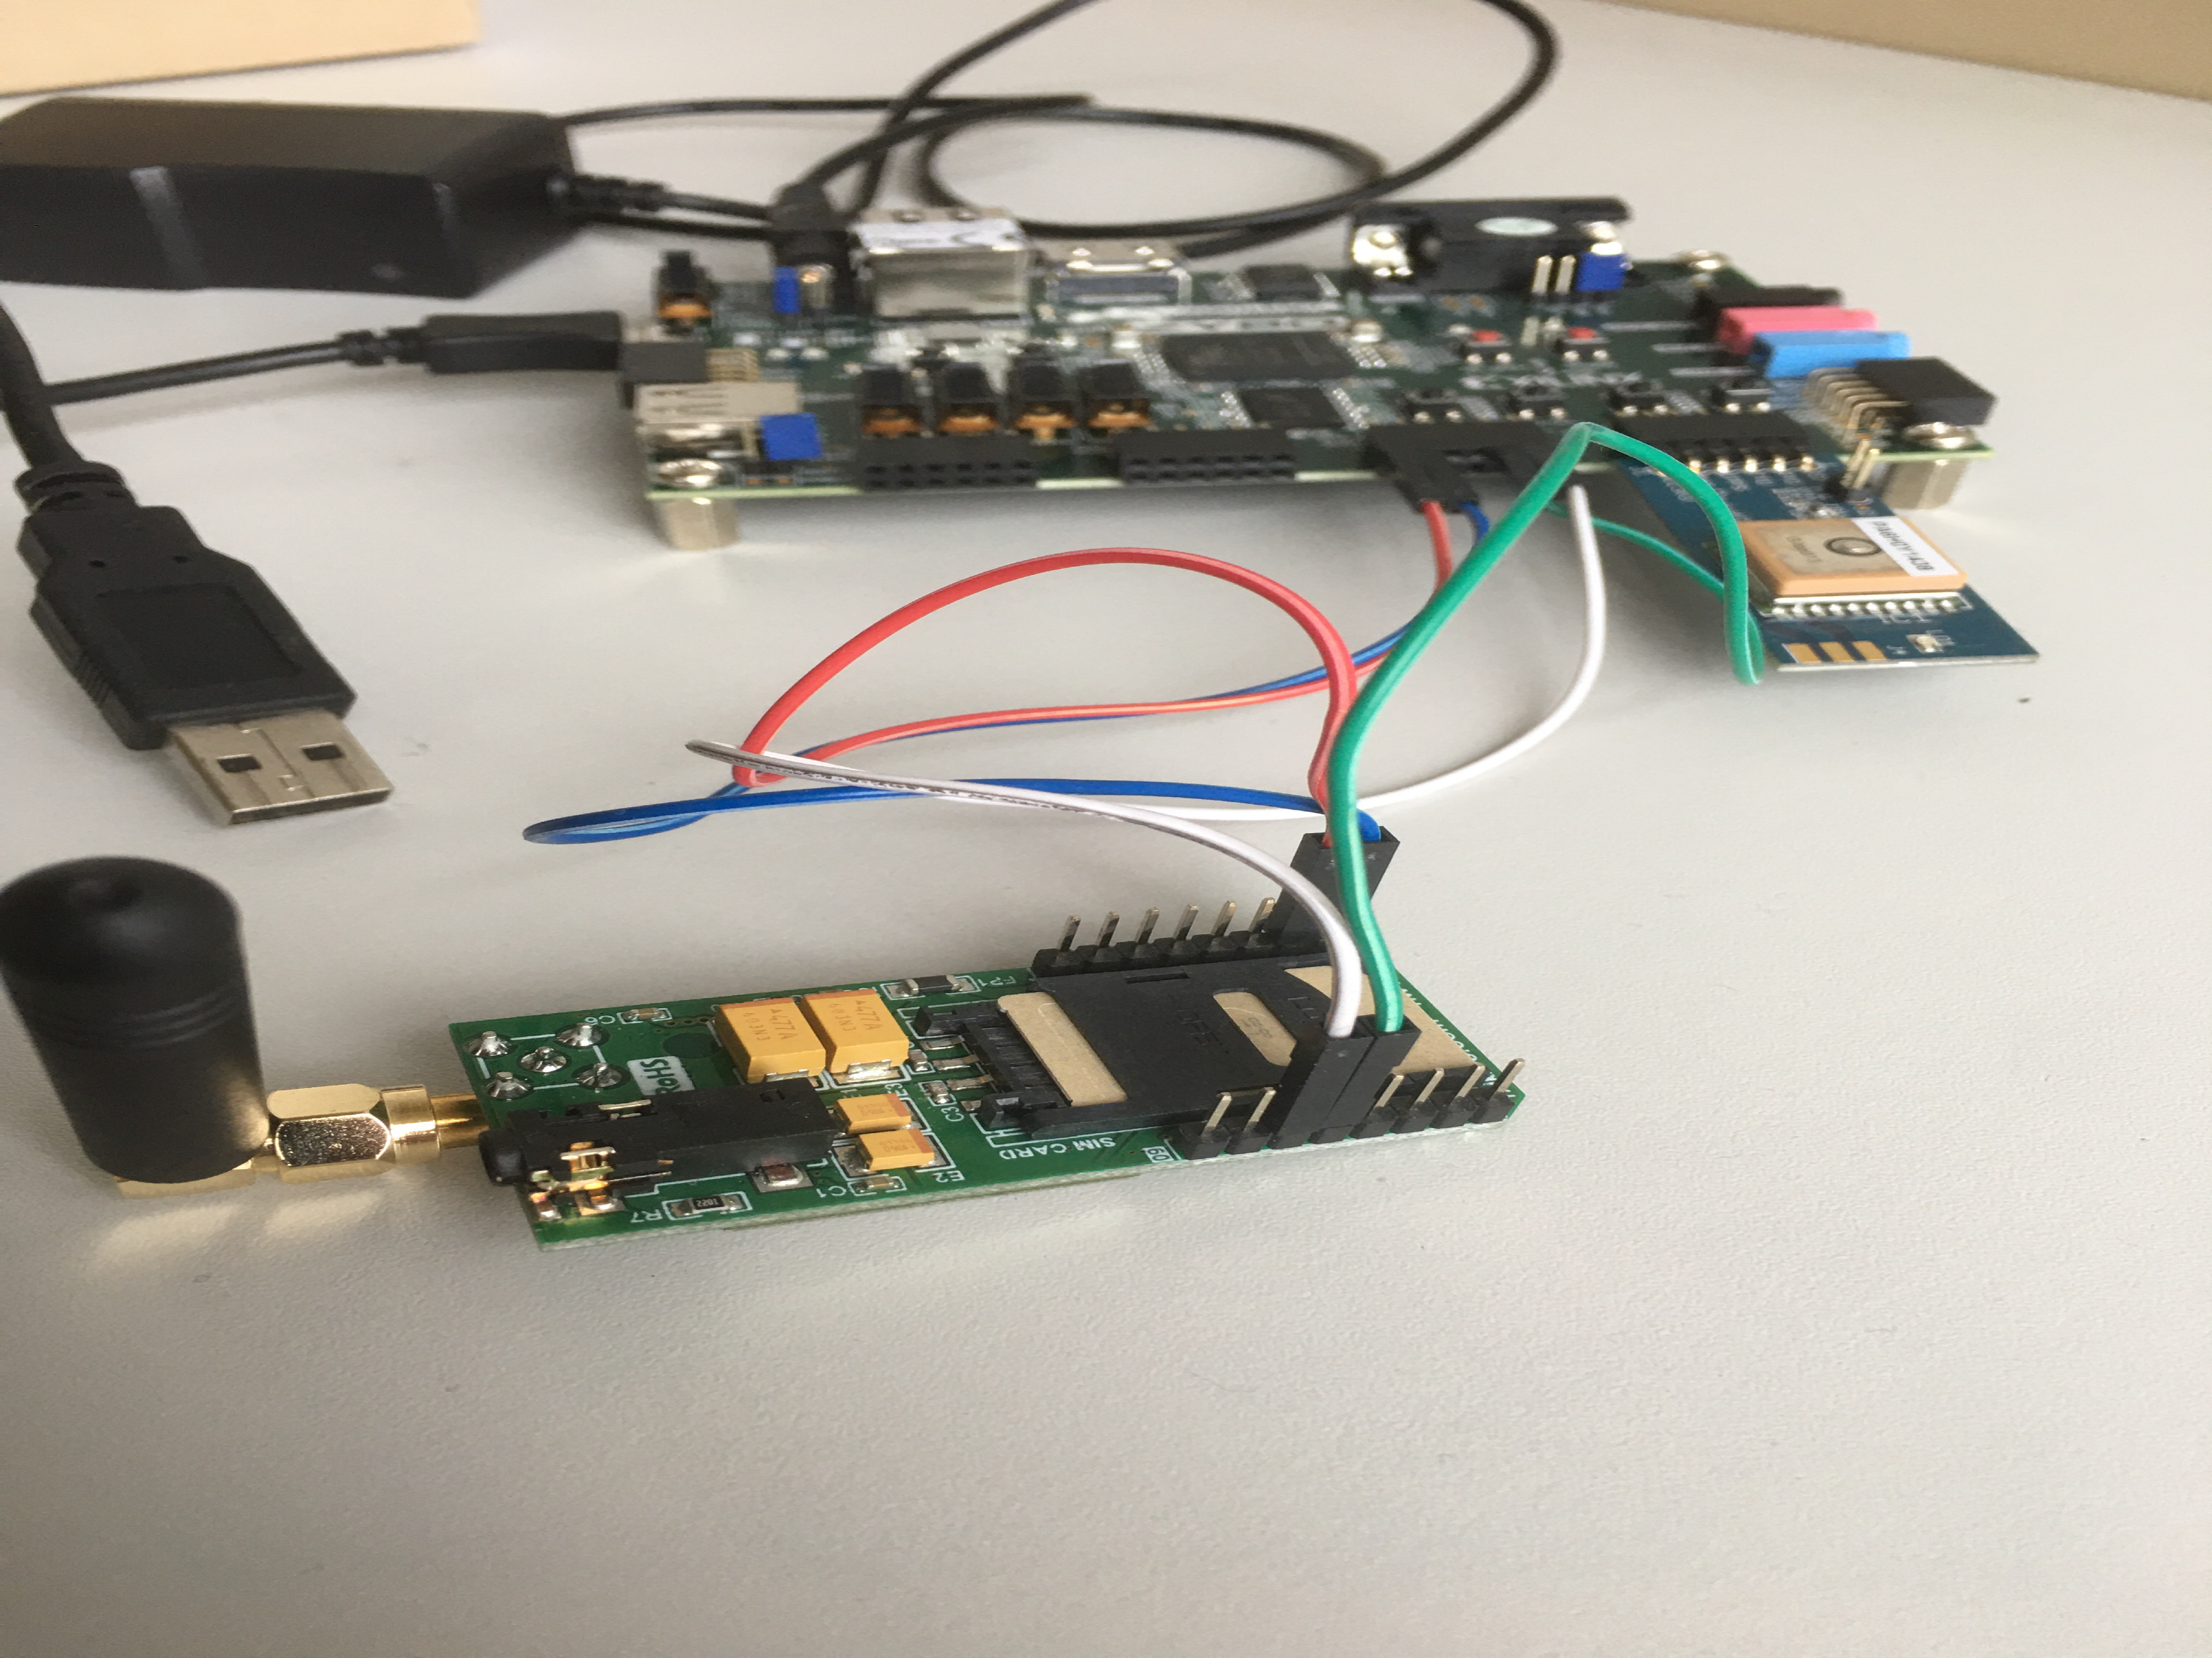

Figure 3. Tracking System on the emulator (Zybo)

“[1]

# III. IMPLEMENTATION AND FUNCTIONALITY TEST

The server presented uses a host PC running a MySQL server ….

# IV. CONCLUSION AND FURTHER WORK

So far, we have shown a server that displays the GSM information and the GPS location on a map, which uses data sent from GPS/GSM module through SMS. All the capabilities shown were implemented on a MySQL server with help of PHP.

Further work – Frontend  
Further possibilities regarding the visualization is nearly endless. Some could e.g. connect multiple datapoints with lines to generate a route, with the help of Google Maps layers. Also, some settings to filter the Data by time, date, region, etc. would be a neat and helpful feature. Those filters could be done completely by JavaScript or by the SQL request of data providing PHP site. The better choice needs to be determined and is mainly affected by the amount of datapoints.

Further work – Backend  
A full security check of the system would be necessary at some point to figure out and fix yet undetected safety concern issues, to provide stability and reliability.

In the future, this could be expanded to also receive Lidar and odometry information, so that it can be implemented for an autonomous driving solution, there most rigorous testing of this new functionalities.

REFERENCES

1. G. Benz, and A. Siggelkow,” Implementation of a GPS and GSM module into a Zynq Z7 SoC based emulator tracking system “, MPC-WORKSHOP FEBRUAR 2020.